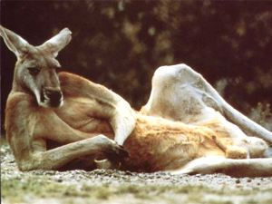
SINGLE, BROWN, KANGAROO, VERY MALE, SEEKS SINGLE, FEMALE KANGAROO TO HOP AROUND, MAKE KANGAROO BABIES AND SHARE GREEN BUSHES. HOBBIES INCLUDE HOPPING, CHEWING ON GREEN STUFF AND HOPING. AGE NOT IMPORTANT. MUST BE A KANGAROO, ENJOY HOPPING AND GREEN STUFF. SERIOUS INQUIRIES ONLY.

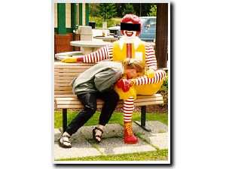
Happy Meal..

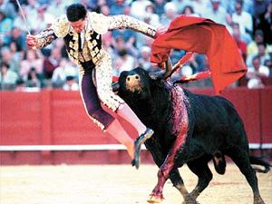
umm, oucho!!


I don’t even know what to say for this one..


Easy John,, Easy… Remember your blood pressure.


3445, WHERE?!?


St. Mary Catherine discovers the wonderful world of online porn…


We have lost many o’ young lady to the Church of the Big Wood.

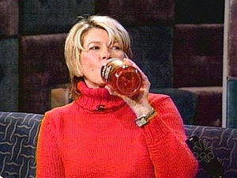
Juicin 40’s with Martha.

