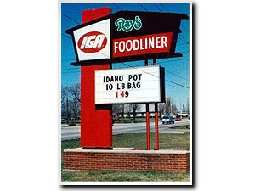
Idaho state legislature puttin the street dealers outta bidness.

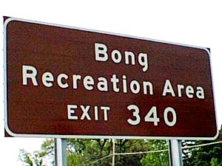
Amazingly, Bob and Dave never made it to their original destination,,, wherever it was.

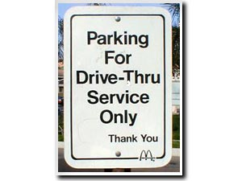
???

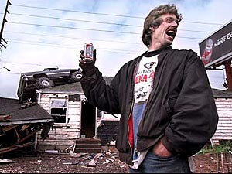
Have another beer dude, tomorrow you won’t find it nearly as funny.

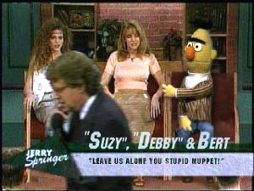
Jerry Springer reaches an all time low.

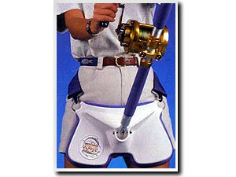
I’m gonna leave this one alone, to many statements about rods, strap-ons, fishy smells, gear, bait and tackle to choose from.

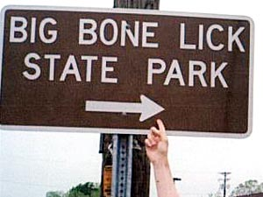
ummm, don’t turn here!!!

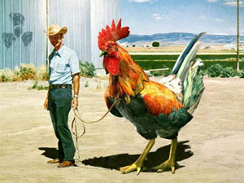
“geez Elmer you’ve got the biggest cock I have ever seen!”


Some things speak for themselves.

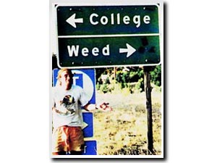
Major dilemma.

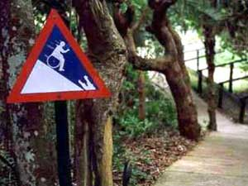
“CAUTION: HANDICAPPED MAN EATING CROCODILE AT BOTTOM OF HILL”

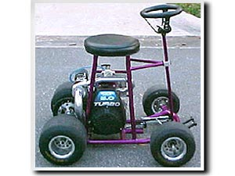
Turbo bar stool, VERY cool.

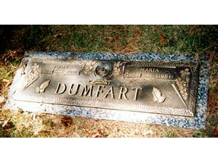
Some times a name change is the best idea…

